**LEBANESE AMERICAN UNIVERSITY**

**USAID – HIGHER EDUCATION SCHOLARSHIP PROGRAM**

**HES - Volunteering Program Verification Form**

This form is to be used to document volunteering hours. If a student volunteers for multiple organizations, a separate form must be used for each organization. **This form must be turned in by the 28th of each month, the latest.**

I certify that the scholar Reem Kraymish completed a total of 5 hours of service at InnovaThrive.

The hours were completed hours as per the below:

Hours # 0 (date) _2/12 – 6/12_ (initials of supervisor) __A.K.___

Hours # 0 (date) _9/12 – 13/12_ (initials of supervisor) __A.K.___

Hours # 0 date) _16/12 – 20/12 (initials of supervisor) __A.K.___

Hours # 5 date) _23/12 - 27/12 (initials of supervisor) __A.K.___

Brief description of the activities the scholar performed or participated in:

I wrote a research report about:  
AI for Optimizing Logistics in Humanitarian Crises  
Definition: Using AI to streamline supply delivery in emergency situations.  
Technologies:  
  
  
Predictive analytics for supply demand forecasting.  
  
  
Drone coordination systems powered by AI.  
  
Applications:  
  
  
Real-time route optimization for emergency deliveries.  
  
  
Monitoring stock levels in disaster zones.  
  
Statistics: AI systems reduce delivery times by 30% in crisis scenarios.  
  
Advantages:  
  
  
Faster response to critical needs.  
  
  
Reduced operational costs for NGOs.  
  
Disadvantages:  
  
  
Accessibility challenges in war-torn or remote areas.  
  
Challenges:  
  
  
Training local responders to work with AI tools.  
  
Future Research:  
  
  
AI for predicting future humanitarian needs.  
  
  
Collaboration with governments for scalable solutions.

Written feedback about the scholar’s performance:

Reem Kraymish’s report on AI for optimizing logistics in humanitarian crises demonstrated AI’s critical role in emergency response, emphasizing faster deliveries and crisis management

Please rate the overall performance of the scholar at your organization:

|  |  |  |  |
| --- | --- | --- | --- |
|  | Mastery (5) | Proficient (3) | Emerging (1) |
| **Problem solver** | X |  |  |
| **Engaged & Committed** | X |  |  |
| **Open-minded & multicultural** | X |  |  |

Signature

& stamp

__________________________

_

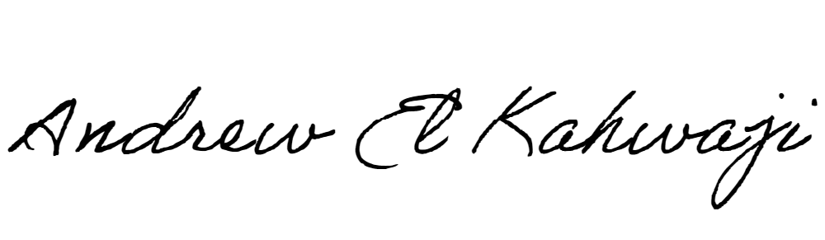

Printed Name _Andrew El Kahwaji_

Date __26/12/2024___

Email __andrew.lifesculptor.coo@gmail.com __

Phone __+961 71 914 378__